User Manual for IFRC Community Sampling Tool

The whole user interface is designed to be very user-friendly and helpful to guide the users.
This is the main steps to follow:
1.Follow the questions to explore your recommended sampling plan.
2.Input the requested figures about your population and relevant parameters.
3.Receive a recommended sampling frame with a PDF export to summaries your response.

In this manual, we also list several features the users might meet when using:

1 Change the language.
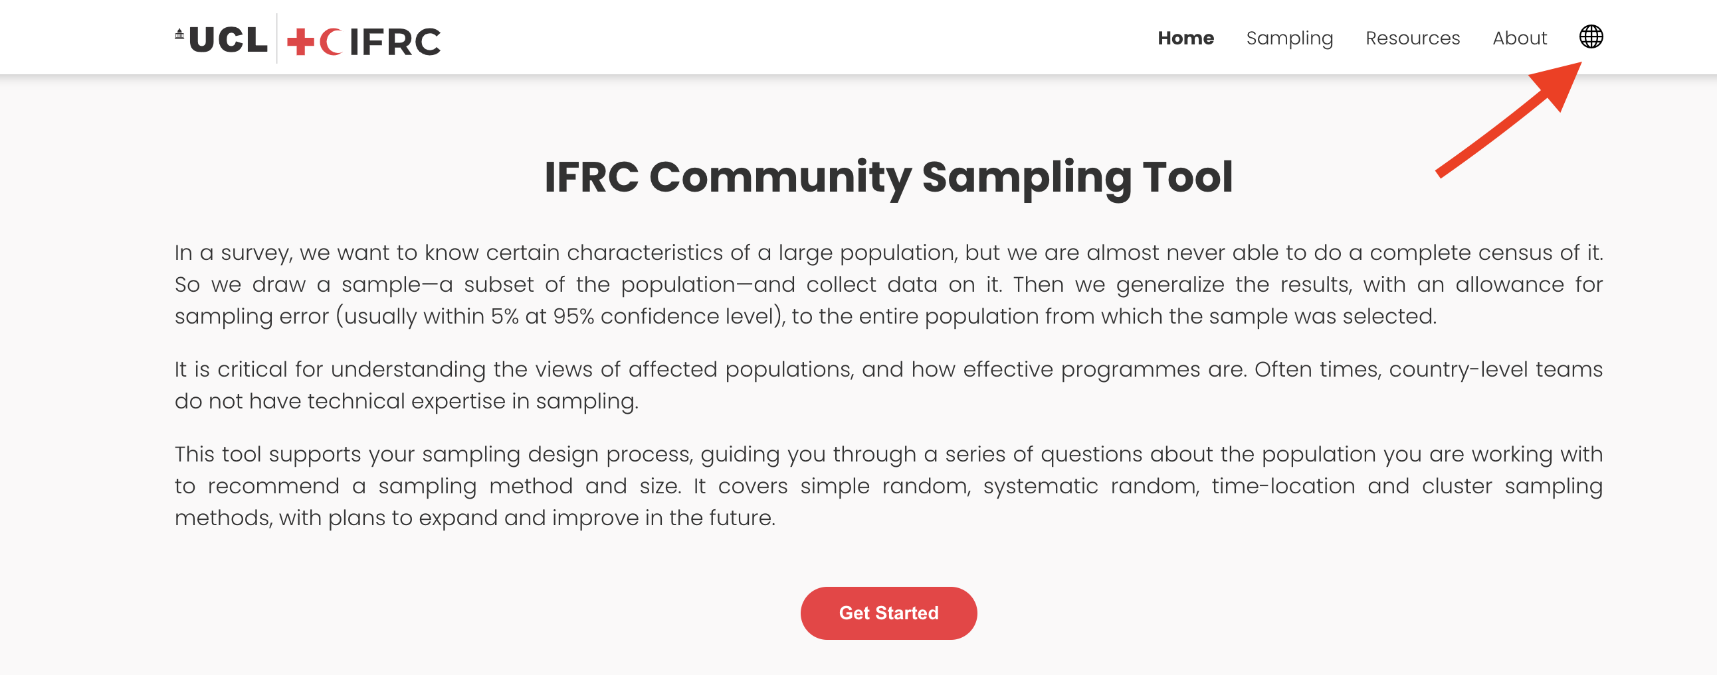
The button for language change is designed as an “globe” sign in the right up corner of our website. In this sampling tool, we provide a range of the language, including: English, French, Spanish and Arabic.

2 Check the terminology.

For review all the terminology might confused you, just click the “Resources” tab in the tool bar and then you could see all the terminologies appear with their definitions. When you encounter one terminology unfamiliar (with the red underline) during the process, you could click it directly and off-canvas would pumped out from the right with the content of definition.
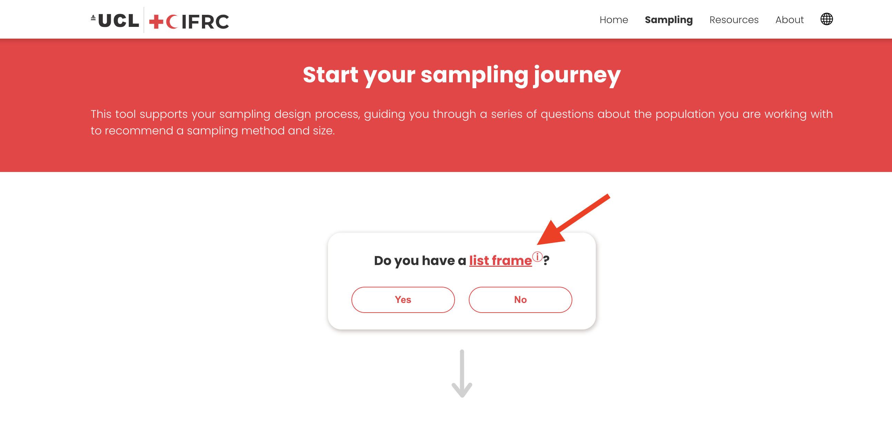
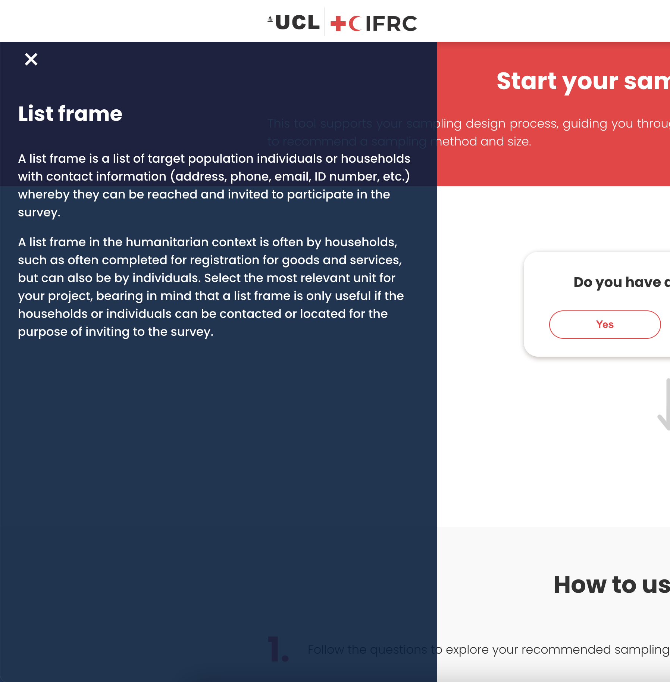

3 Export the PDF
To make the result storable and portable, the users can export the sampling survey into a PDF document, together with any notes or reminders they would like to add. When the result is finished, the export button would automatically pumped out below the result box.
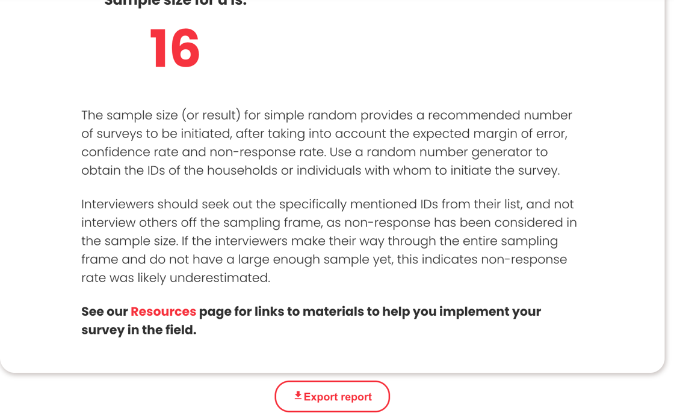

4 Validity Check and Alarms
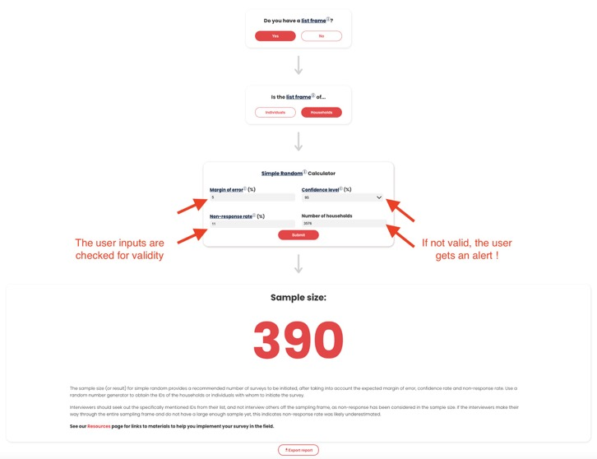

Every set of input would be checked by the validity automatically. And as shown in the above graph, an alert would pumped out immediately.

